Silhouette metric for img011001.jpg is: 0.7276658777855657

Davies Bouldin metric for img011001.jpg is: 0.2862207377150997

Calinski Harabasz metric for img011001.jpg is: 58491.28357303285

ID 0: (905, 439)

ID 1: (1052, 182)

ID 2: (1130, 574)

ID 3: (103, 477)

ID 4: (965, 292)

ID 5: (1048, 540)

ID 6: (1736, 445)

ID 7: (937, 817)

ID 8: (1374, 557)

ID 9: (932, 915)

ID 10: (890, 656)

ID 11: (1556, 450)

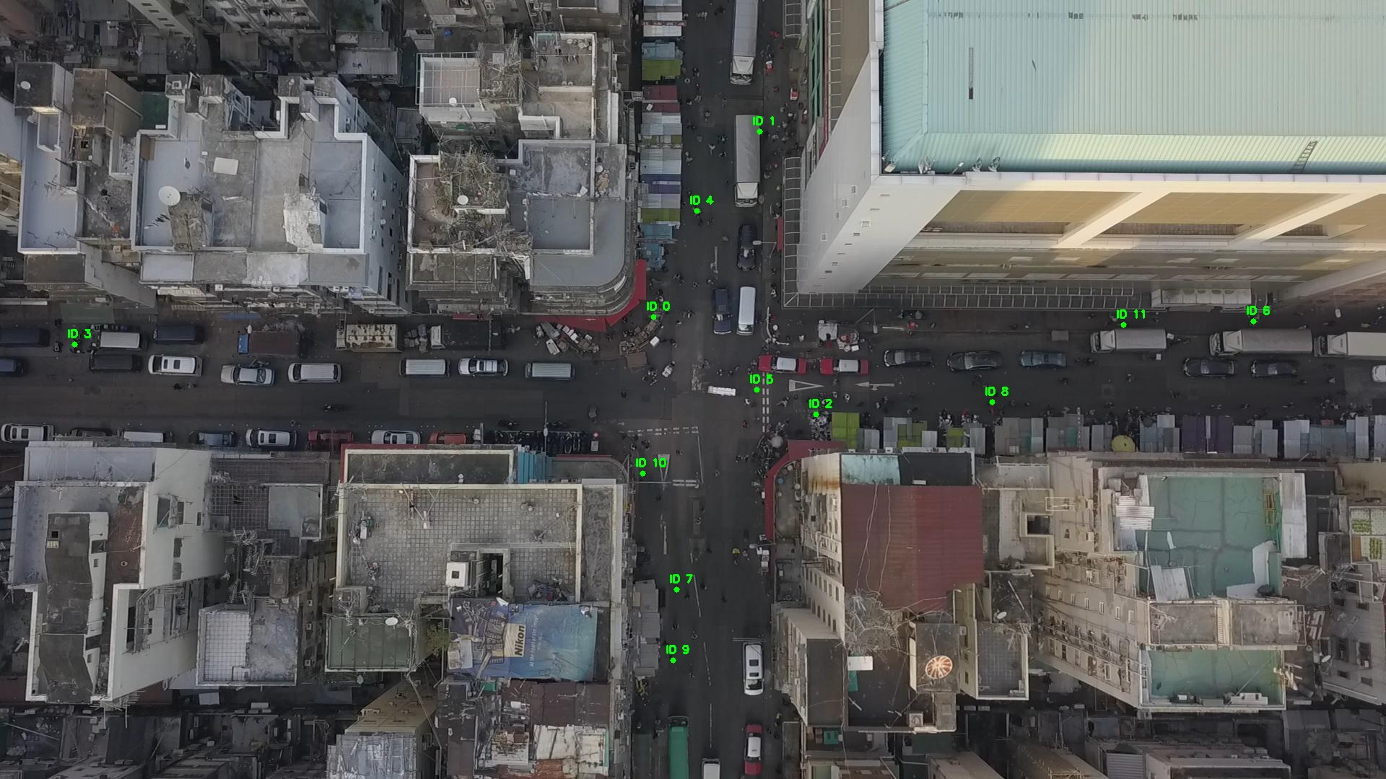

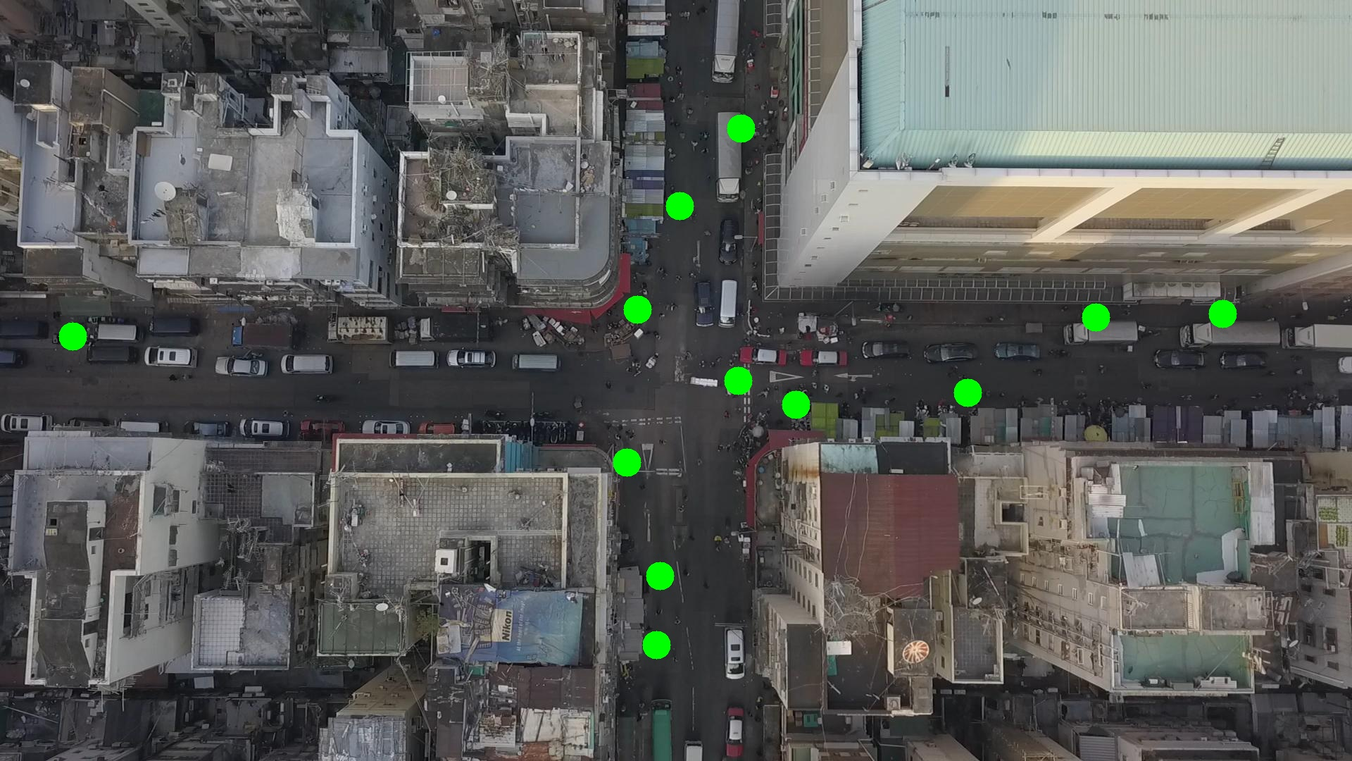

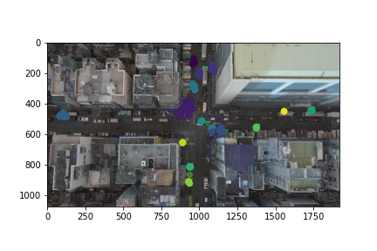

Silhouette metric for img011002.jpg is: 0.7135951889964198

Davies Bouldin metric for img011002.jpg is: 1.3258274710815663

Calinski Harabasz metric for img011002.jpg is: 21044.782135702764

ID 0: (893, 450)

ID 1: (1087, 173)

ID 2: (1119, 575)

ID 3: (102, 479)

ID 4: (966, 292)

ID 5: (1012, 514)

ID 6: (1736, 445)

ID 7: (936, 831)

ID 8: (1373, 559)

ID 9: (932, 915)

ID 10: (890, 655)

ID 11: (1551, 448)

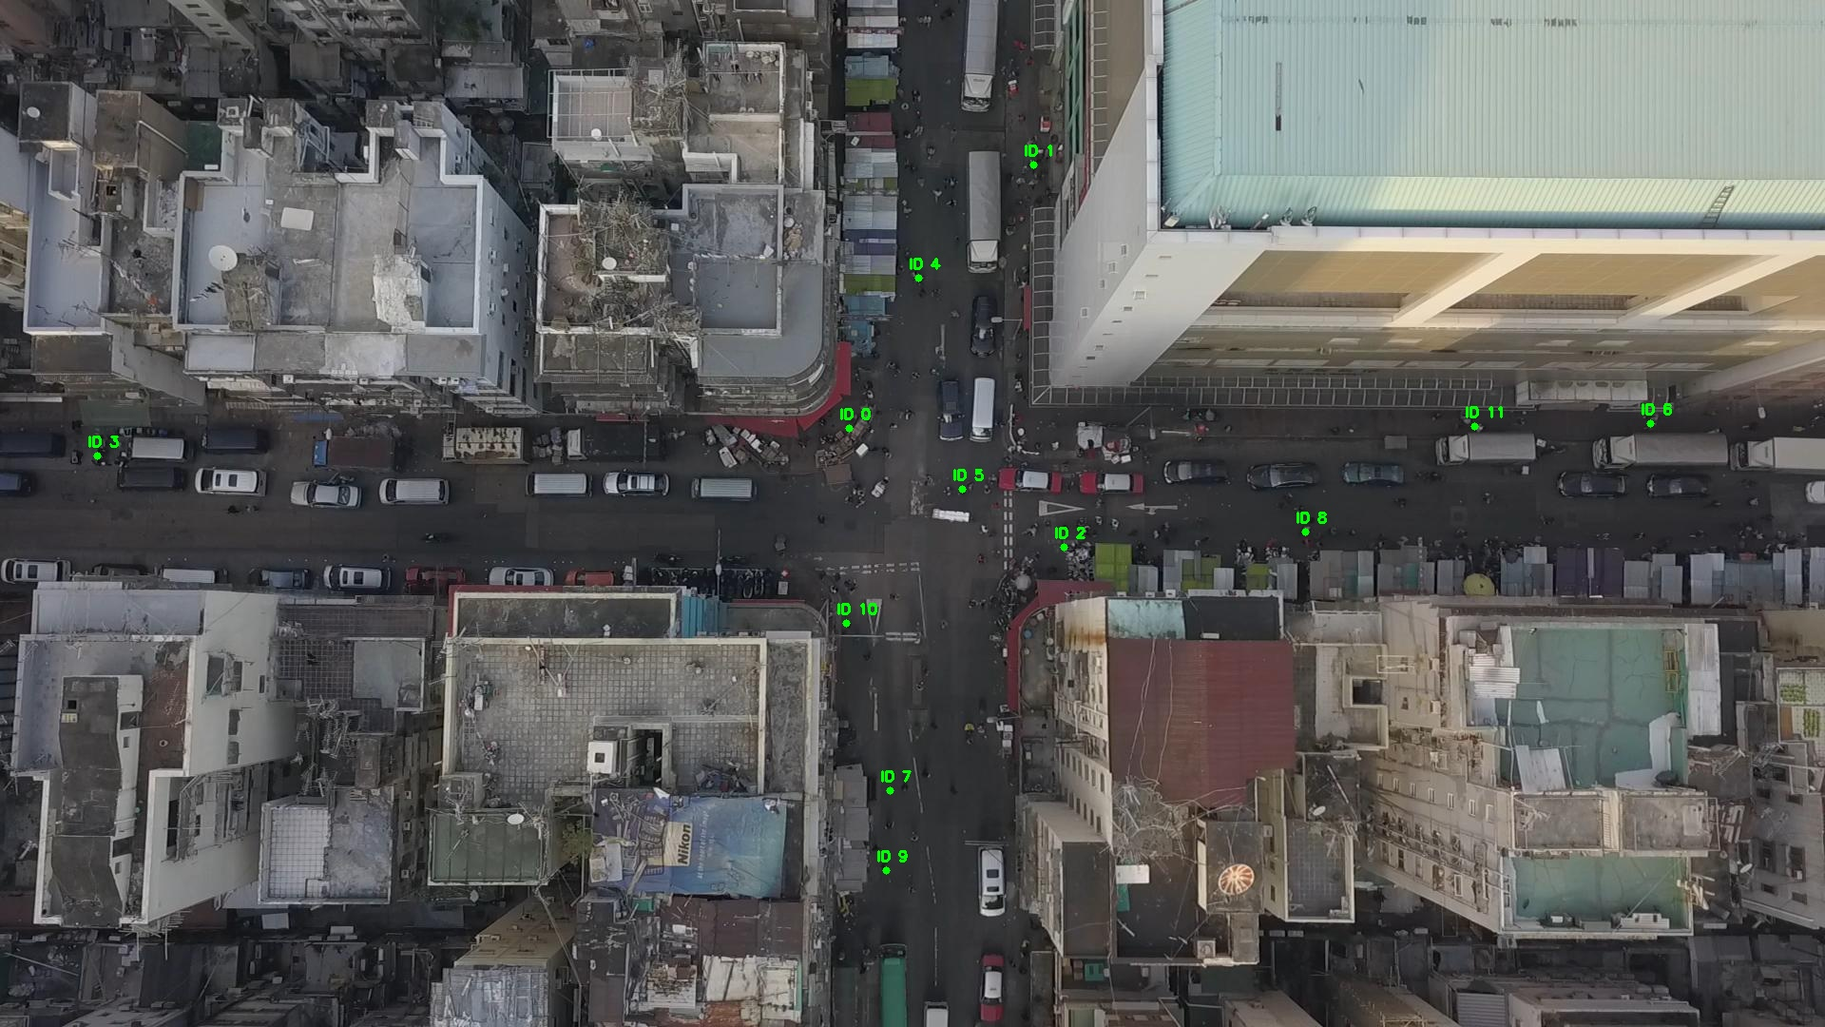

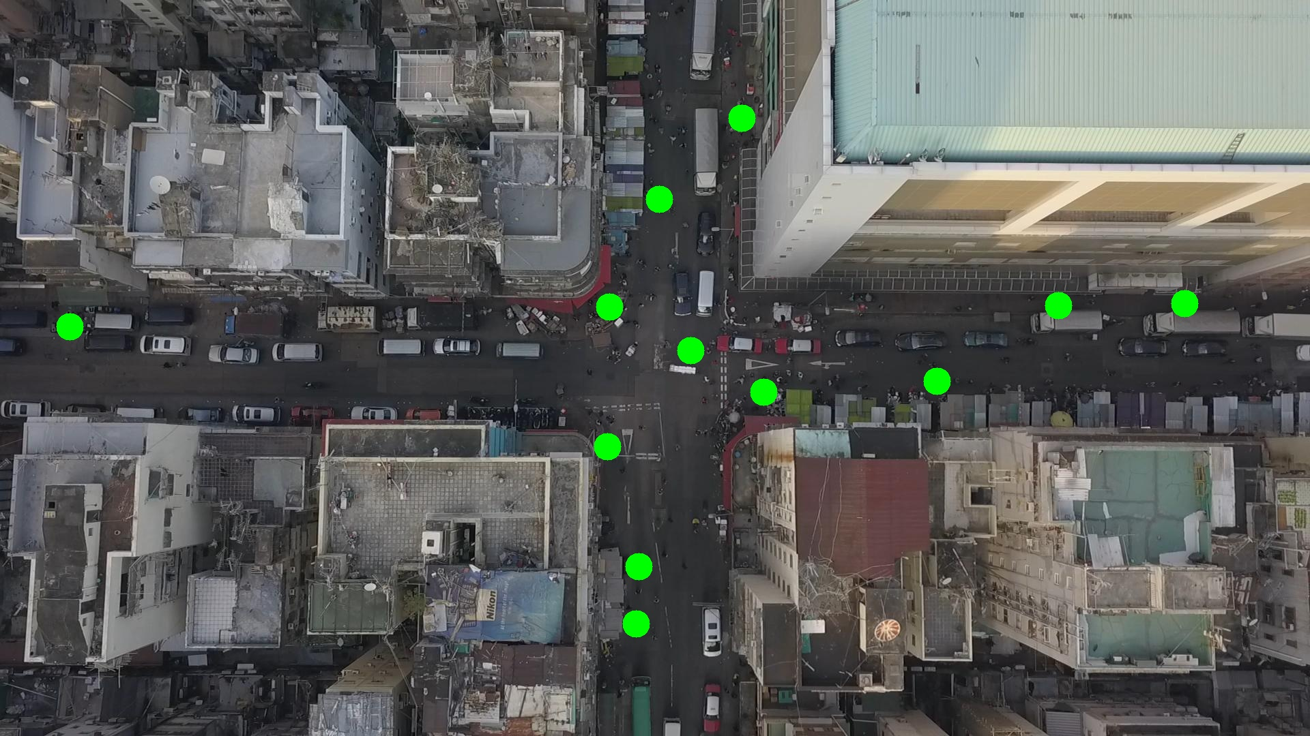

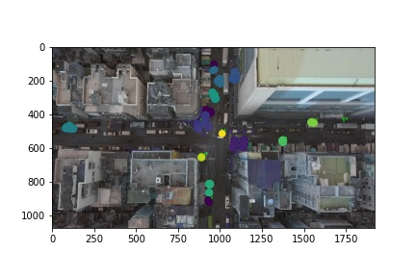

Silhouette metric for img011003.jpg is: 0.6294184923612394

Davies Bouldin metric for img011003.jpg is: 0.33023438773164143

Calinski Harabasz metric for img011003.jpg is: 63169.79621285446

ID 0: (906, 415)

ID 1: (1088, 177)

ID 2: (1112, 569)

ID 3: (100, 479)

ID 4: (945, 332)

ID 5: (1011, 515)

ID 6: (1736, 445)

ID 7: (937, 831)

ID 8: (1376, 555)

ID 9: (932, 915)

ID 10: (890, 656)

ID 11: (1562, 451)

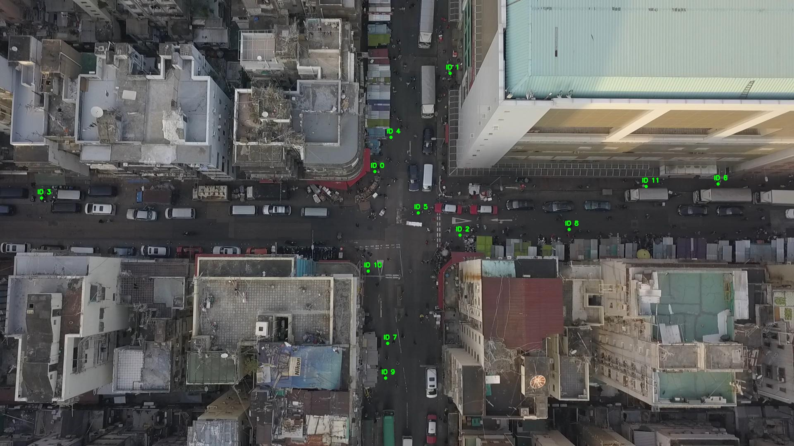

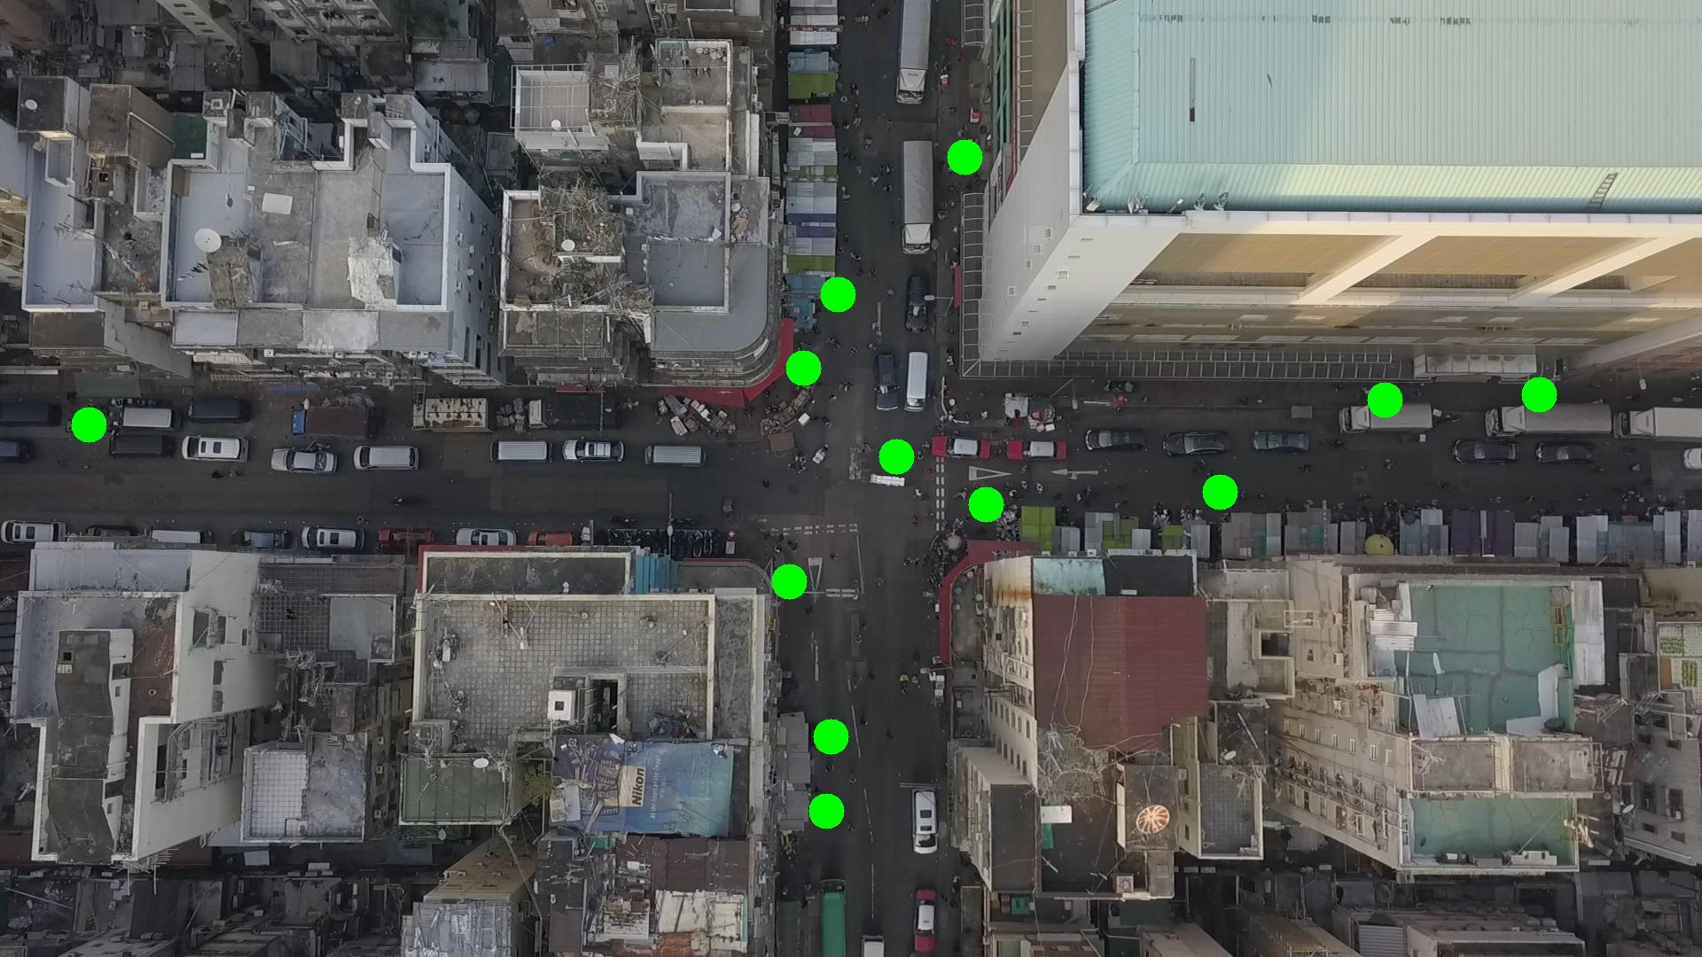

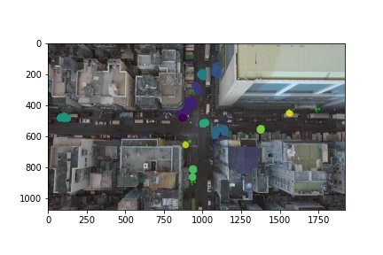

Silhouette metric for img011004.jpg is: 0.7162184434925816

Davies Bouldin metric for img011004.jpg is: 0.40811307320727636

Calinski Harabasz metric for img011004.jpg is: 37697.157249355965

ID 0: (904, 430)

ID 1: (1085, 178)

ID 2: (1114, 566)

ID 3: (101, 478)

ID 4: (964, 290)

ID 5: (979, 498)

ID 6: (1736, 445)

ID 7: (937, 814)

ID 8: (1366, 548)

ID 9: (929, 909)

ID 10: (890, 655)

ID 11: (1562, 451)

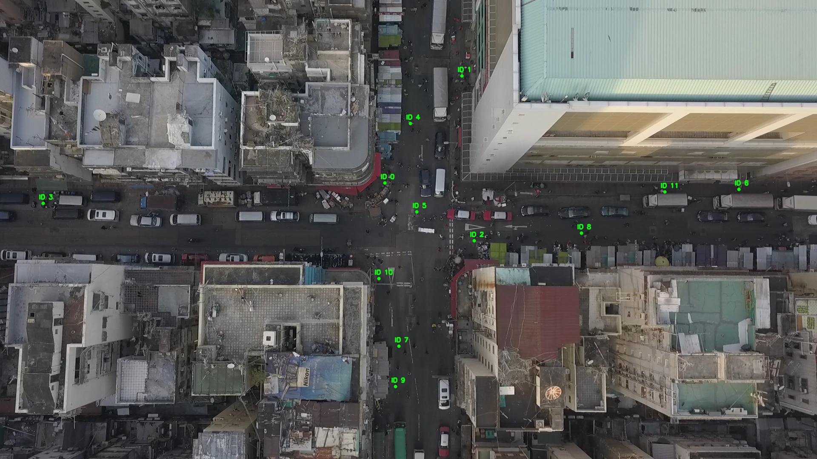

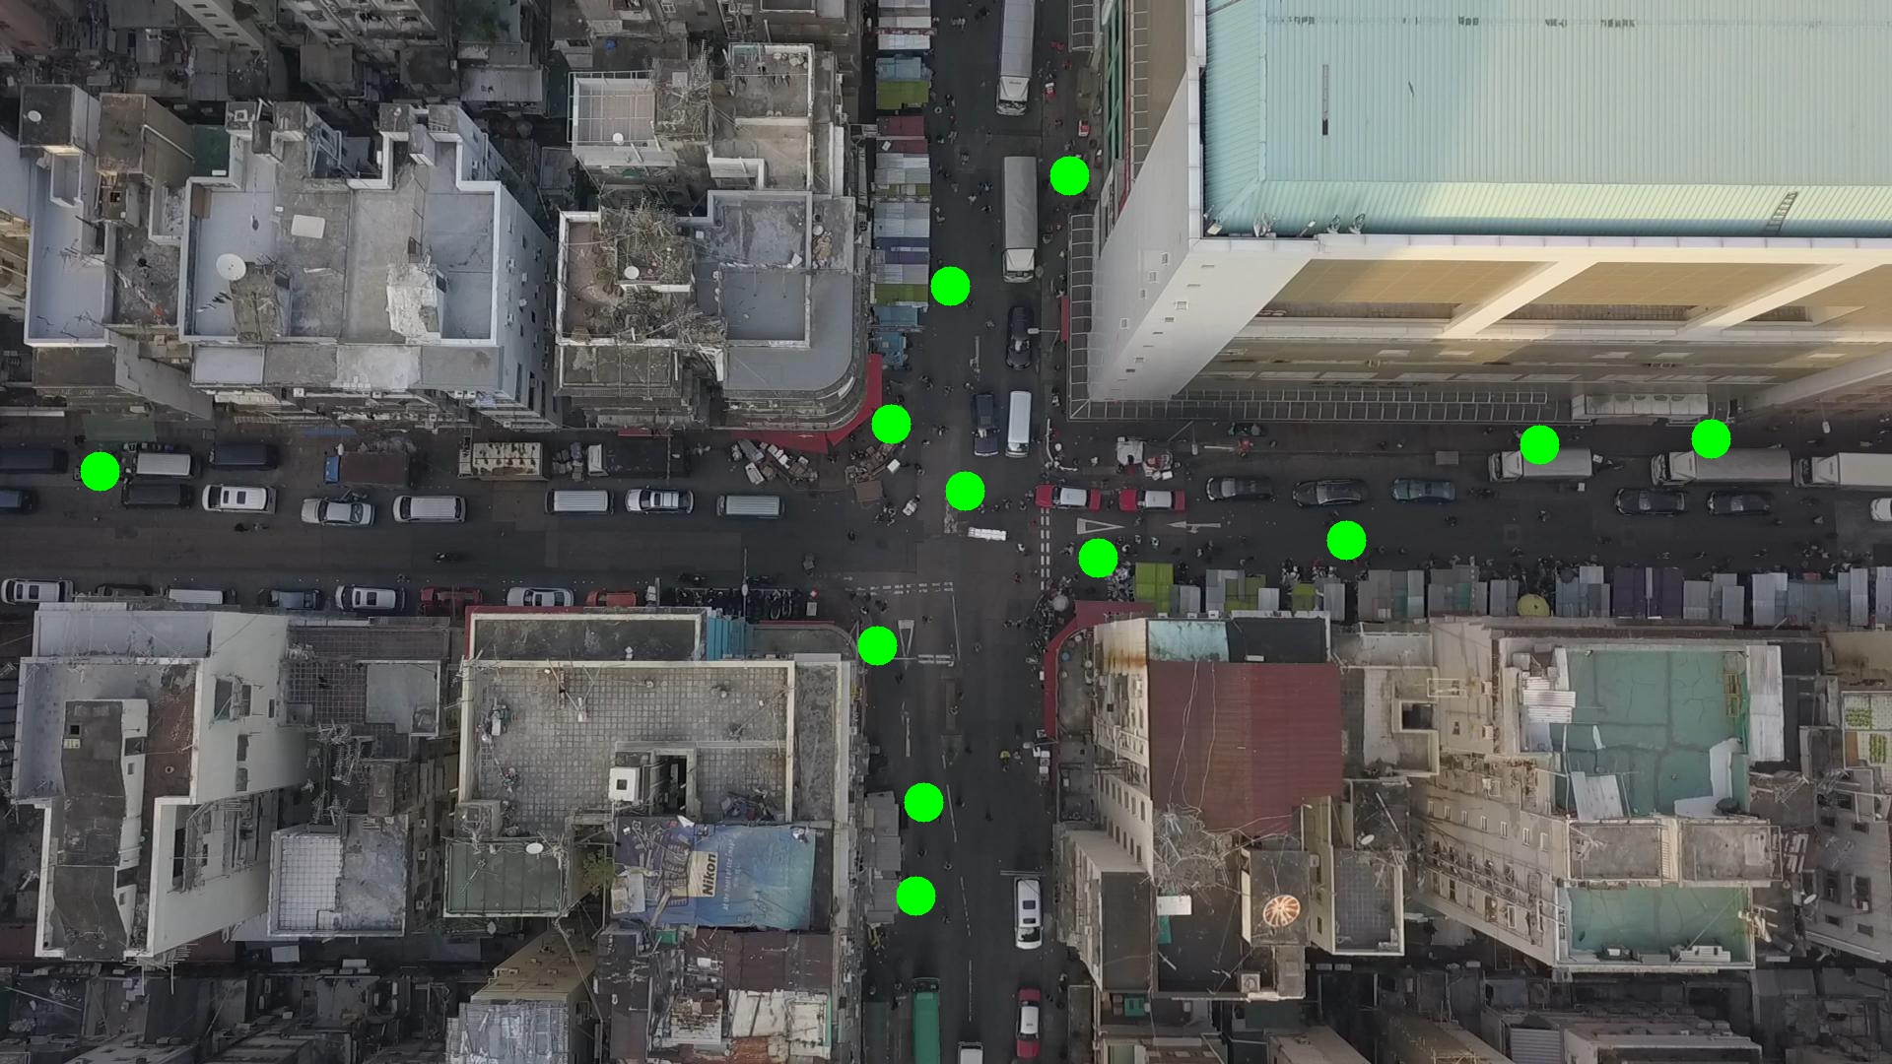

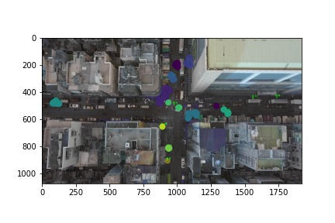

Silhouette metric for img011005.jpg is: 0.5791108783424346

Davies Bouldin metric for img011005.jpg is: 1.7002275892106475

Calinski Harabasz metric for img011005.jpg is: 22072.965941145838

ID 0: (920, 390)

ID 1: (1056, 184)

ID 2: (1114, 574)

ID 3: (103, 477)

ID 4: (965, 290)

ID 5: (978, 497)

ID 6: (1736, 445)

ID 7: (937, 814)

ID 8: (1376, 555)

ID 9: (935, 862)

ID 10: (891, 654)

ID 11: (1562, 451)

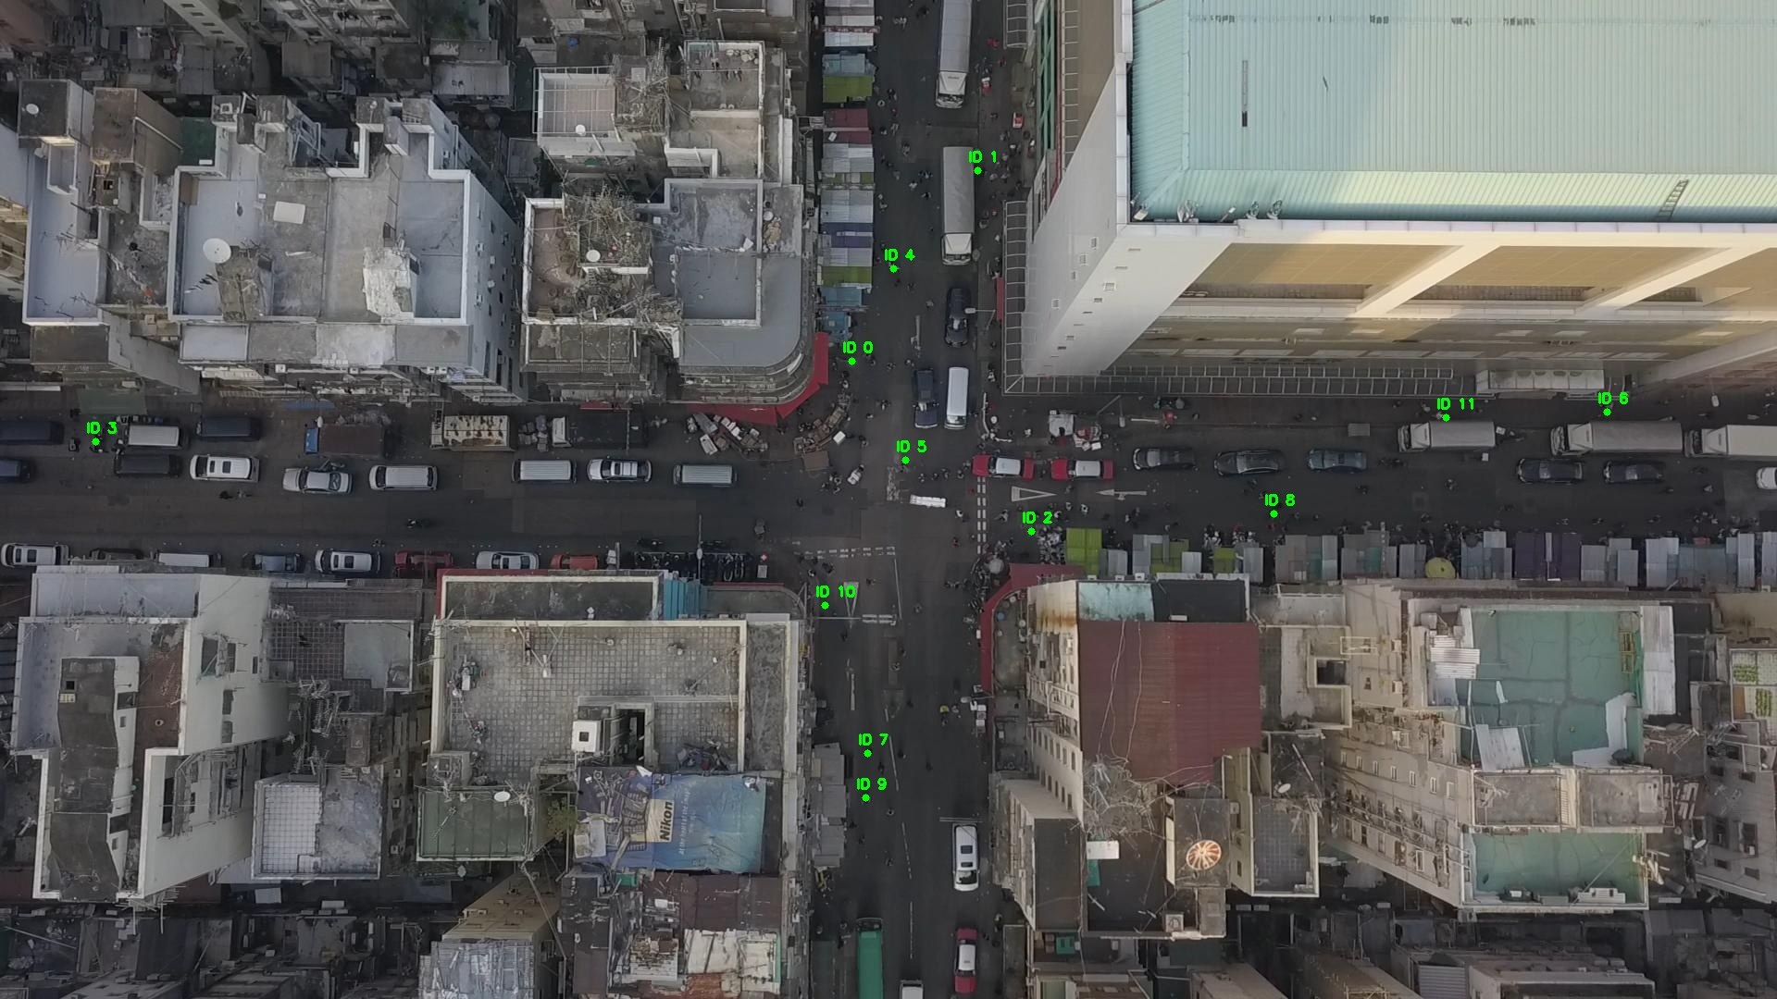

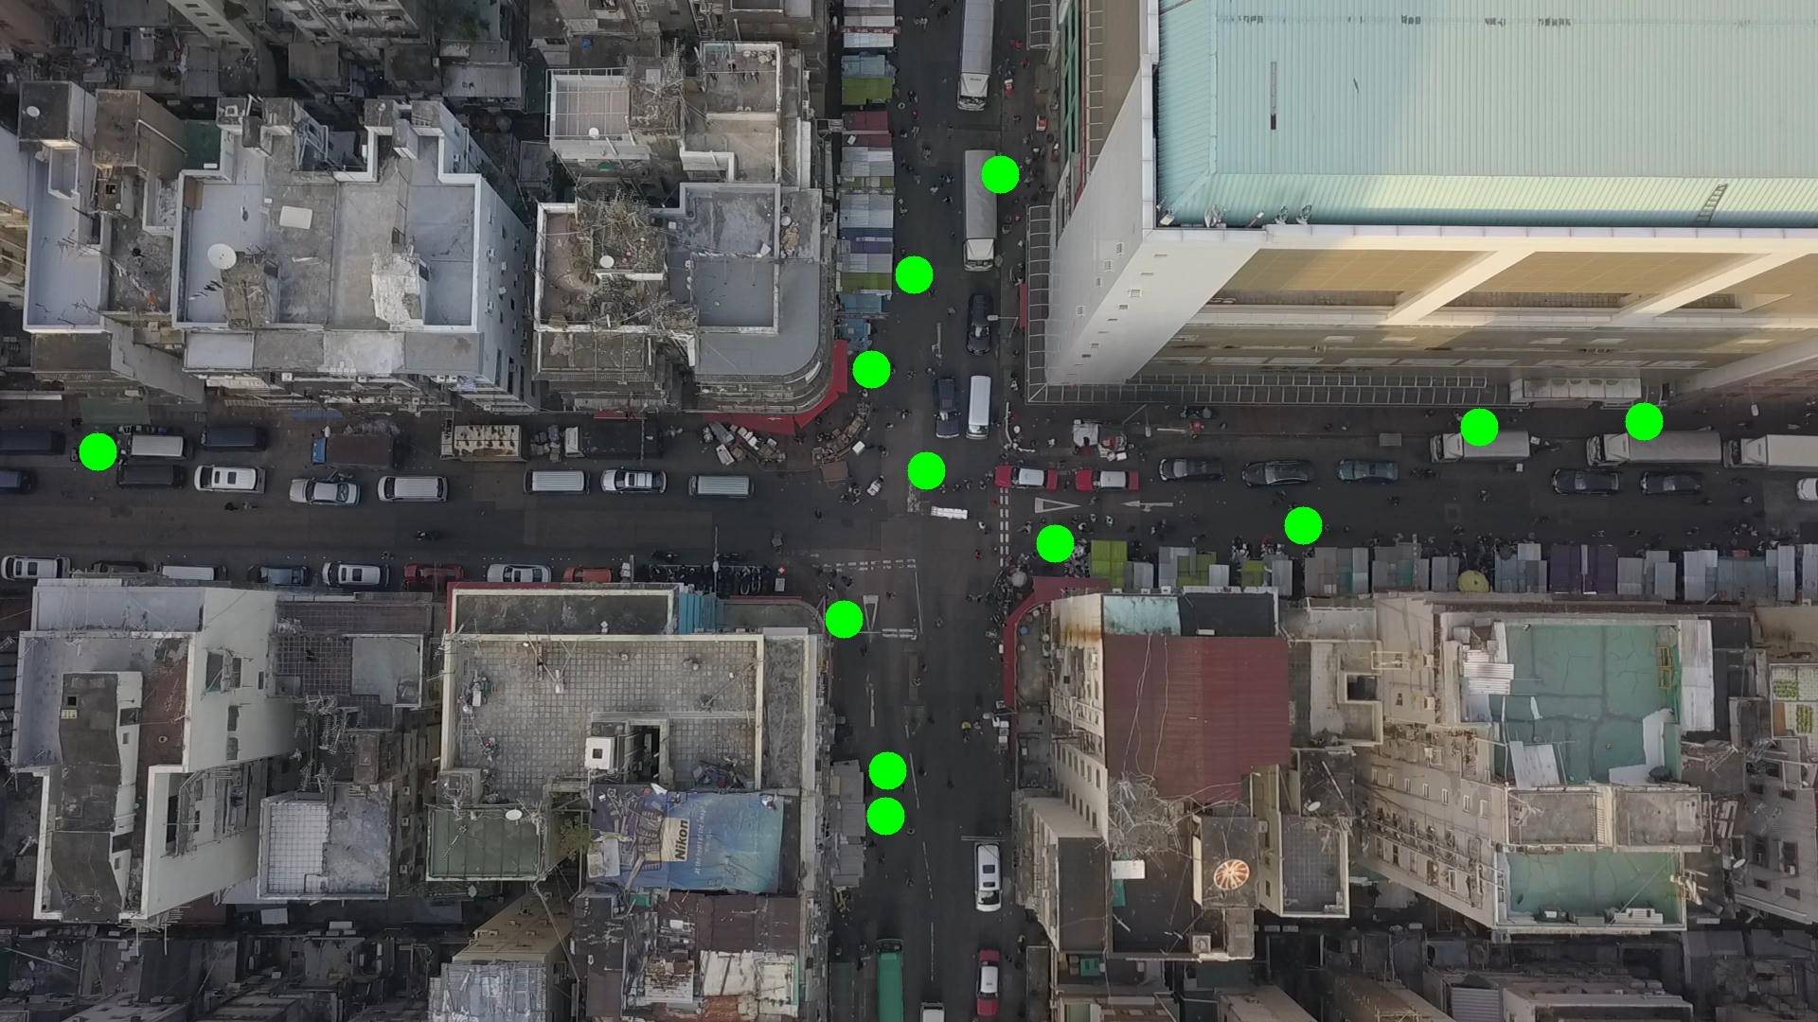

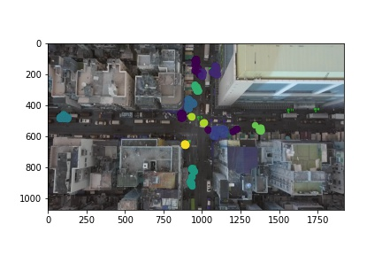

Silhouette metric for img011006.jpg is: 0.6776138943967234

Davies Bouldin metric for img011006.jpg is: 0.958724583023326

Calinski Harabasz metric for img011006.jpg is: 84130.68456495472

ID 0: (905, 422)

ID 1: (1090, 168)

ID 2: (1122, 576)

ID 3: (103, 478)

ID 4: (966, 290)

ID 5: (978, 497)

ID 6: (1736, 445)

ID 7: (937, 814)

ID 8: (1362, 539)

ID 9: (938, 858)

ID 10: (892, 655)

ID 11: (1562, 451)

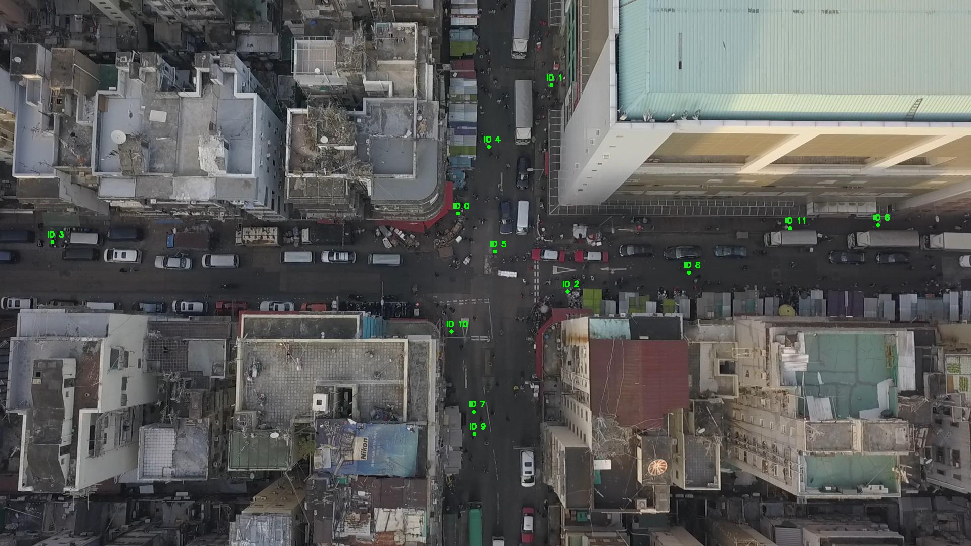

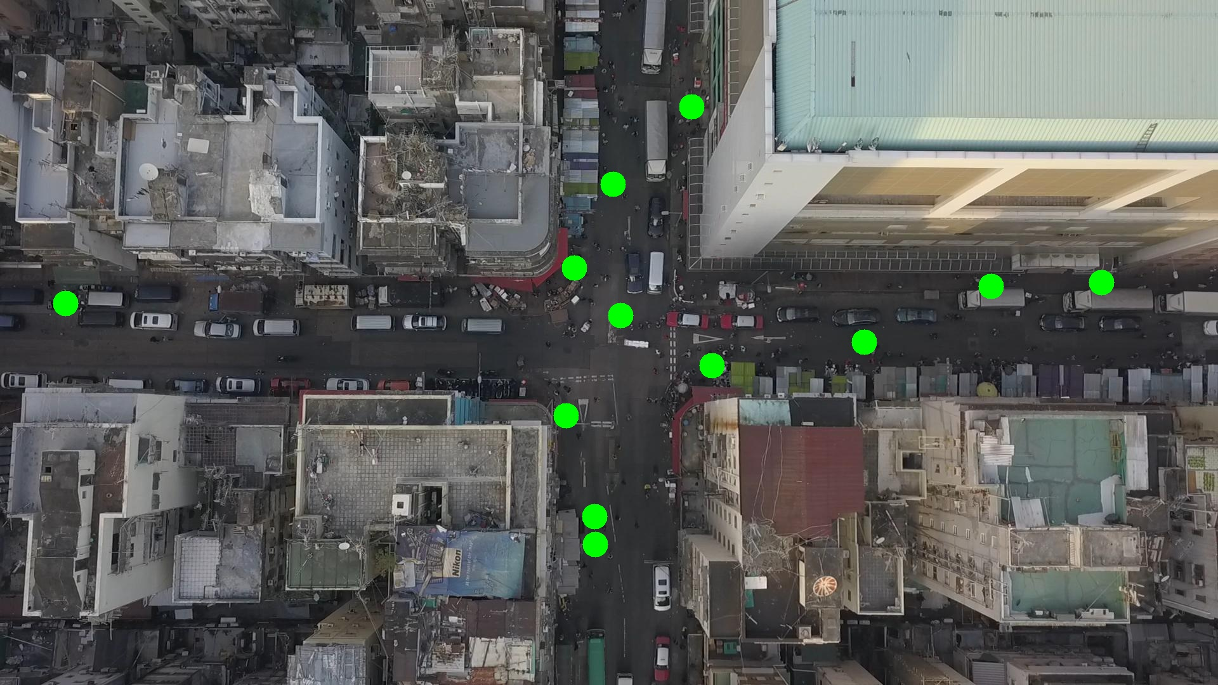

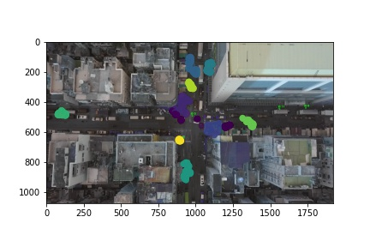

Silhouette metric for img011007.jpg is: 0.6447459985711255

Davies Bouldin metric for img011007.jpg is: 1.0697653215974827

Calinski Harabasz metric for img011007.jpg is: 45576.45089872133

ID 0: (920, 387)

ID 1: (1088, 169)

ID 2: (1120, 580)

ID 3: (103, 477)

ID 4: (964, 288)

ID 5: (900, 468)

ID 6: (1736, 445)

ID 7: (937, 814)

ID 8: (1367, 543)

ID 9: (938, 864)

ID 10: (892, 654)

ID 11: (1562, 451)

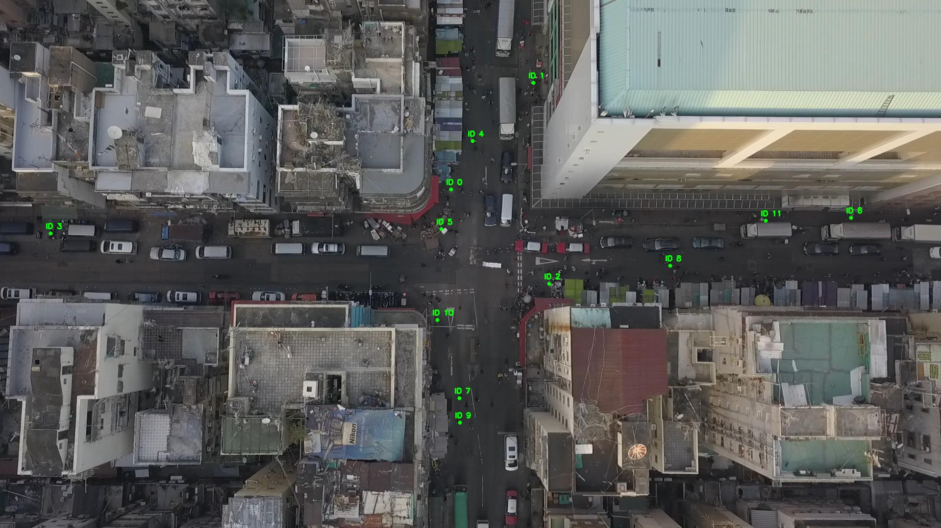

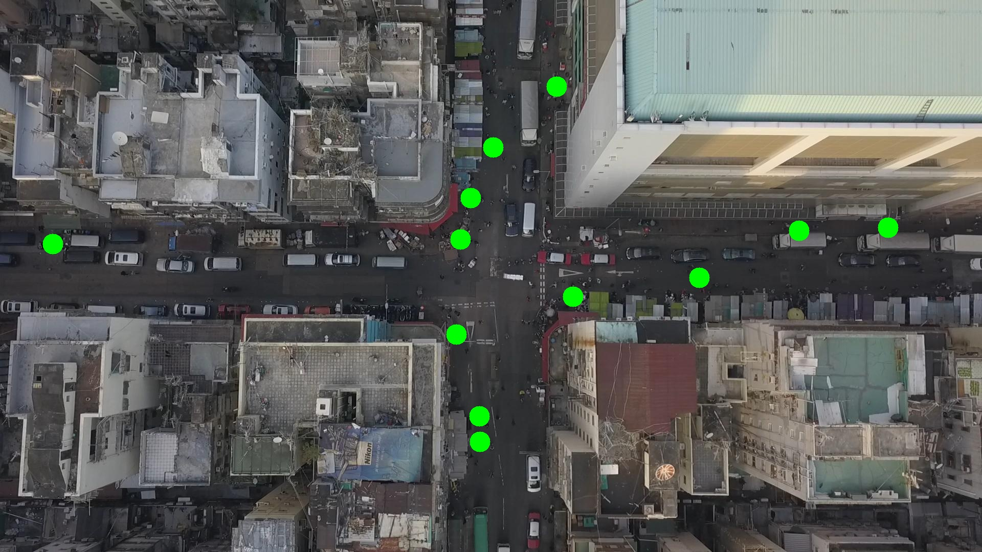

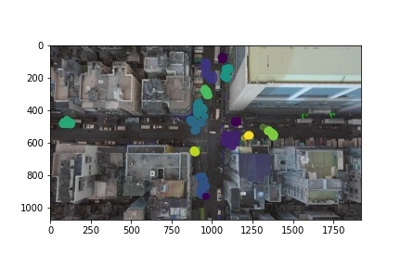

Silhouette metric for img011008.jpg is: 0.6355059425196243

Davies Bouldin metric for img011008.jpg is: 1.3487671530043803

Calinski Harabasz metric for img011008.jpg is: 61644.87599427034

ID 0: (918, 383)

ID 1: (1085, 172)

ID 2: (1120, 582)

ID 3: (103, 478)

ID 4: (984, 186)

ID 5: (891, 499)

ID 6: (1736, 445)

ID 7: (937, 814)

ID 8: (1368, 547)

ID 9: (936, 864)

ID 10: (892, 653)

ID 11: (1530, 451)

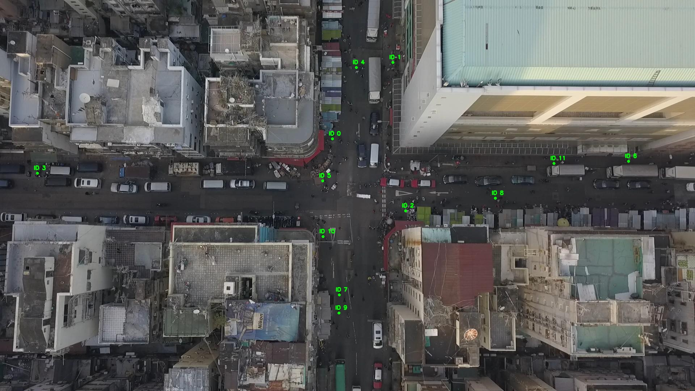

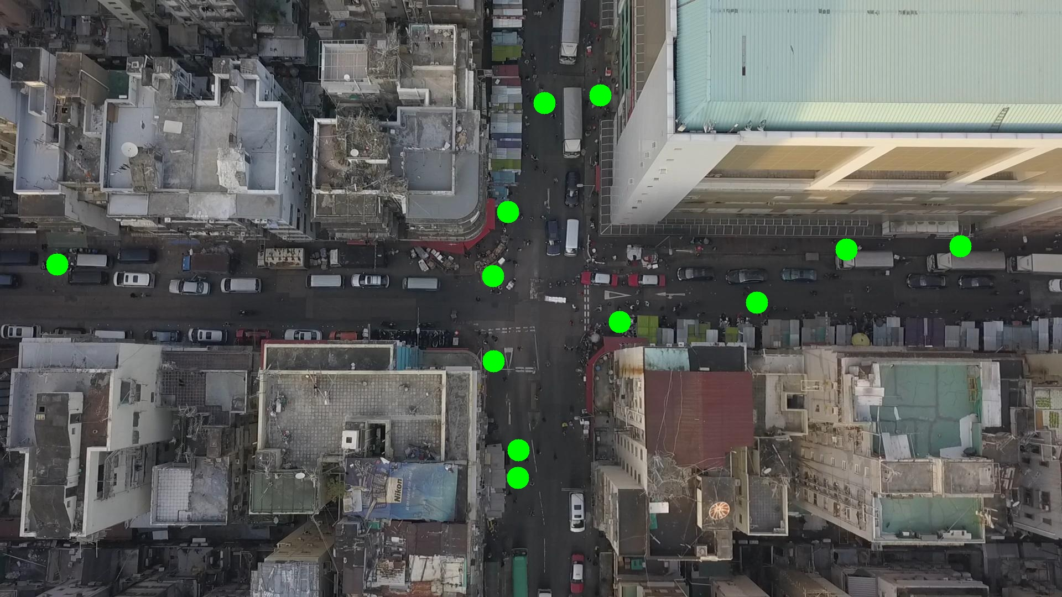

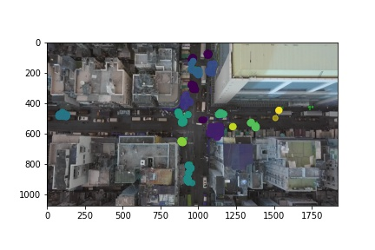

Silhouette metric for img011009.jpg is: 0.6848283223844769

Davies Bouldin metric for img011009.jpg is: 1.6473237835438812

Calinski Harabasz metric for img011009.jpg is: 46530.44818824847

ID 0: (919, 387)

ID 1: (1046, 182)

ID 2: (1123, 583)

ID 3: (104, 477)

ID 4: (976, 167)

ID 5: (900, 504)

ID 6: (1736, 445)

ID 7: (937, 814)

ID 8: (1373, 549)

ID 9: (937, 861)

ID 10: (891, 651)

ID 11: (1530, 447)

ID 12: (1073, 1007)

ID 13: (1120, 468)

ID 14: (1235, 1044)

ID 15: (963, 287)

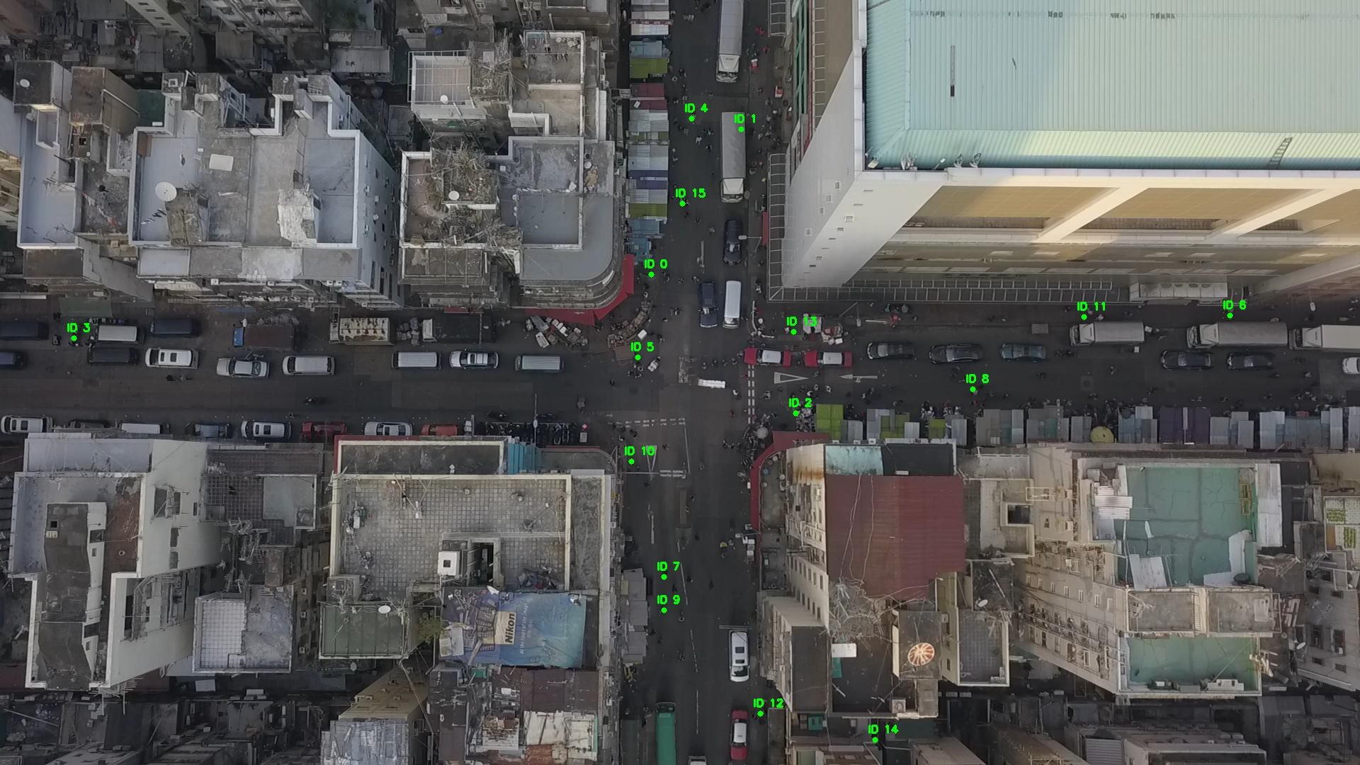

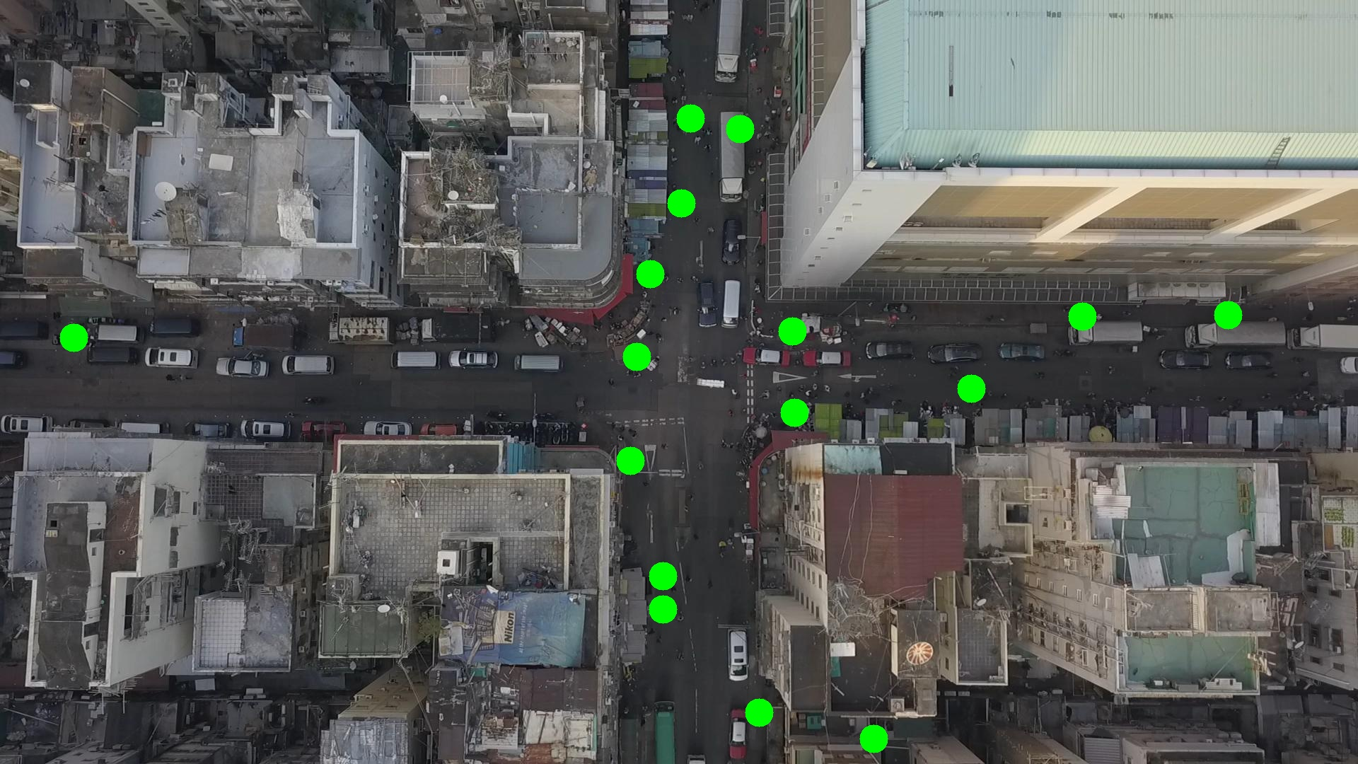

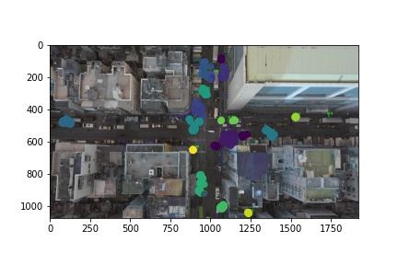

Silhouette metric for img011010.jpg is: 0.7049635046797471

Davies Bouldin metric for img011010.jpg is: 0.567464049964941

Calinski Harabasz metric for img011010.jpg is: 136741.15215224083

ID 0: (917, 387)

ID 1: (1053, 181)

ID 2: (1124, 582)

ID 3: (104, 478)

ID 4: (977, 164)

ID 5: (891, 497)

ID 6: (1736, 445)

ID 7: (937, 814)

ID 8: (1372, 548)

ID 9: (939, 850)

ID 10: (893, 653)

ID 11: (1530, 447)

ID 12: (1072, 1006)

ID 13: (1057, 481)

ID 14: (1237, 1045)

ID 15: (963, 286)

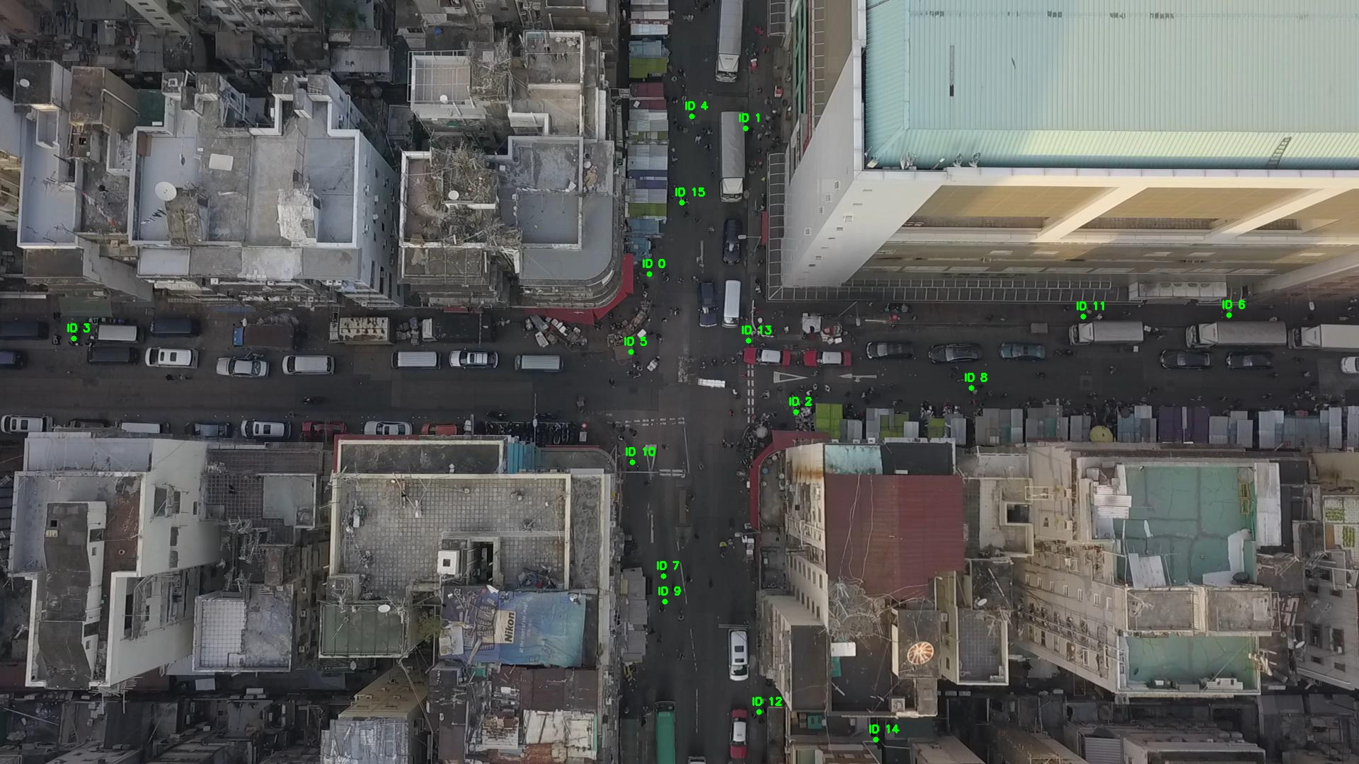

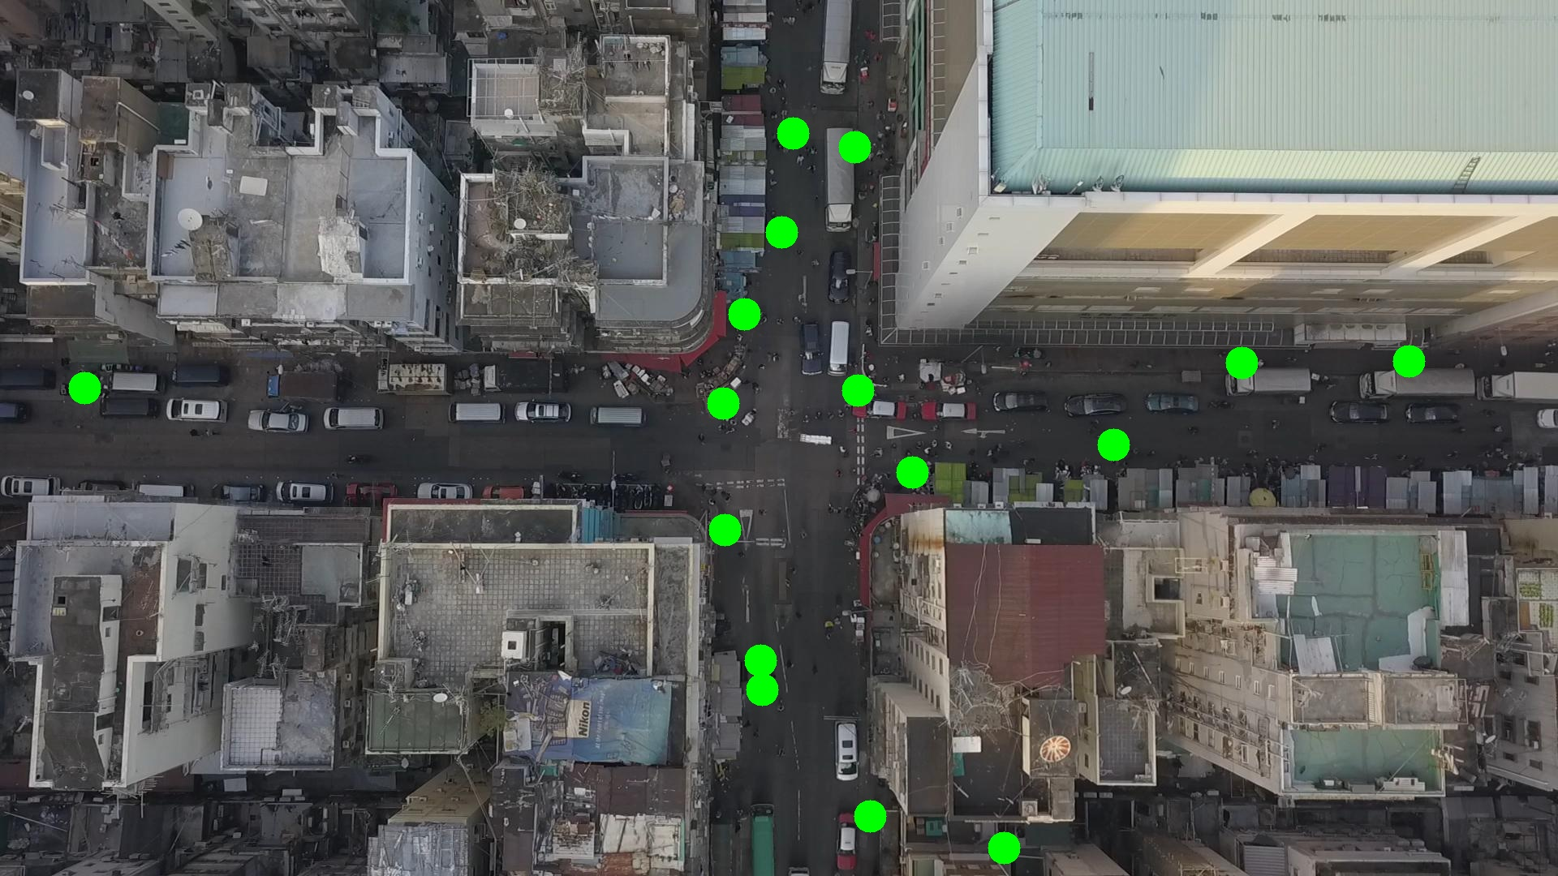

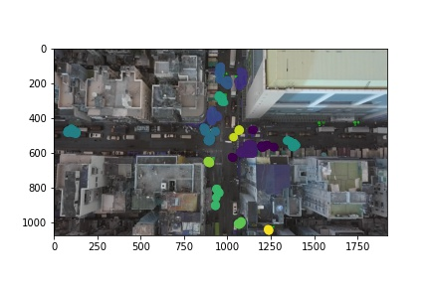

Silhouette metric for img011011.jpg is: 0.6773960350995677

Davies Bouldin metric for img011011.jpg is: 0.9548103690170048

Calinski Harabasz metric for img011011.jpg is: 50788.579955051035

ID 0: (916, 385)

ID 1: (1082, 172)

ID 2: (1121, 581)

ID 3: (103, 477)

ID 4: (975, 166)

ID 5: (896, 522)

ID 6: (1850, 554)

ID 7: (937, 814)

ID 8: (1364, 543)

ID 9: (941, 865)

ID 10: (892, 651)

ID 11: (1530, 447)

ID 12: (1069, 1010)

ID 13: (1057, 481)

ID 14: (1237, 1046)

ID 15: (963, 286)

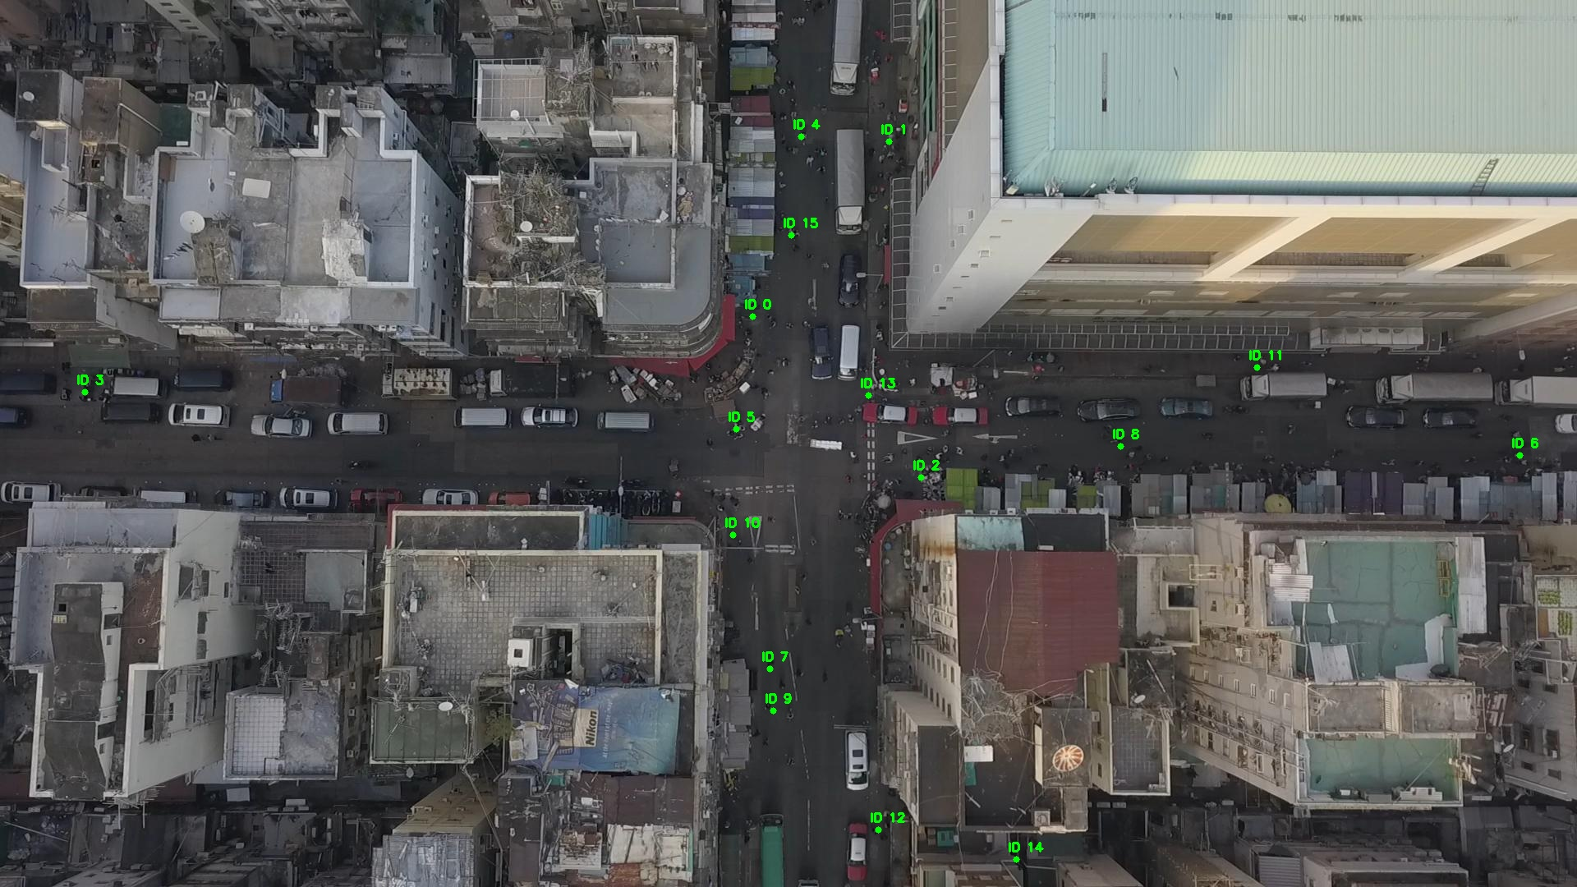

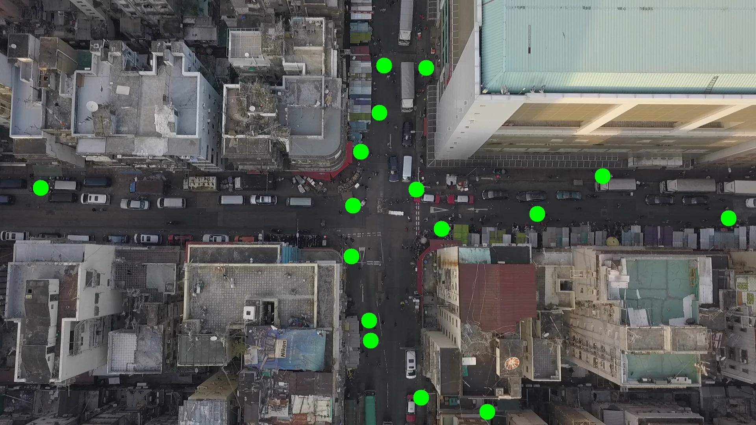

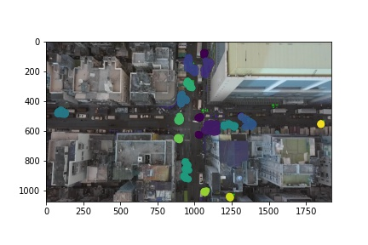

Silhouette metric for img011012.jpg is: 0.701739426840701

Davies Bouldin metric for img011012.jpg is: 1.428824475014681

Calinski Harabasz metric for img011012.jpg is: 85293.19771359628

ID 0: (920, 391)

ID 1: (1081, 173)

ID 2: (1120, 582)

ID 3: (103, 477)

ID 4: (981, 170)

ID 5: (901, 506)

ID 6: (1850, 554)

ID 7: (937, 814)

ID 8: (1365, 539)

ID 9: (942, 855)

ID 10: (889, 651)

ID 11: (1530, 447)

ID 12: (1071, 1007)

ID 13: (1065, 467)

ID 14: (1236, 1045)

ID 15: (962, 284)

